EV3 Switch-Loop Assessment
- What is the difference between this version of the Orchard Challenge and the original version in the Turning Chapter?
- For an Obstacle Detection program, what does the Switch-Loop do, and how does it do this?

- Besides distance, what are other ways to control the duration of an Obstacle Detection Switch-Loop?

- Why doesn't this program work for Obstacle Detection?

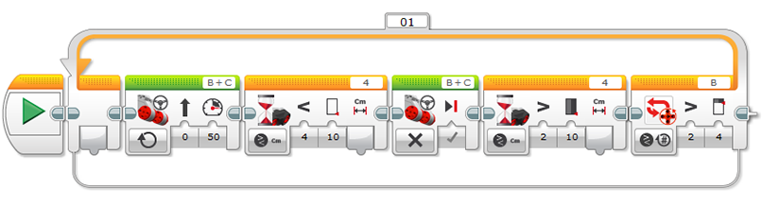

5. Ziffle writes this straight line Obstacle Detection program. What happens when the program is run? What does Ziffle need to do to improve it? Why?
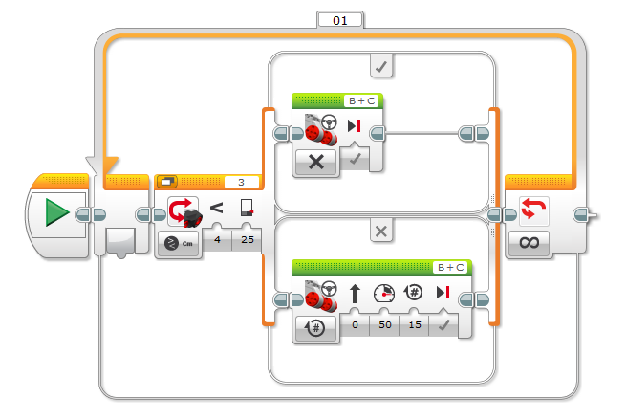
6. Ziffle wants this robot to run all night. How long will it run? Why?
